Our last lesson ended halfway through Paul’s 2nd missionary journey. He had taken Silas and traveled to the churches in Asia that had been founded on his 1st missionary trip. Timothy had joined the trip and they had sailed to Macedonia and traveled through Philippi, Thessalonica, and on to Berea. There had been great revival among the Bereans until the opposition that had stirred up trouble in Thessalonica caught up with Paul in Berea. To save Paul’s life, some of the Berean brethren had escorted Paul to the coast to get on a ship to get away from the opposition. Silas and Timothy remained behind helping found the church in Berea.

Acts 17:15 Now those who escorted Paul brought him as far as Athens; and receiving a command for Silas and Timothy to come to him as soon as possible, they left.

Paul boarded a ship for the mainland of Greece and landed in the city of Athens. Athens was one of the most magnificent cities in the world at that time, and it was the capital city of Greece and was the center of Grecian art, philosophy, and government. The city was famous for it's debates and love for new thoughts and ideas. It was also known for its idolatry and even today Athens has monuments to many gods throughout it's streets.

Acts 17:16-17 Now while Paul was waiting for them at Athens, his spirit was being provoked within him as he was observing the city full of idols. 17 So he was reasoning in the synagogue with the Jews and the God-fearing Gentiles, and in the market place every day with those who happened to be present.

As Paul looked around at the rampant idolatry his spirit was stirred and, instead of waiting for Silas and Timothy, Paul began to teach and dispute the false doctrines of the city with the Jewish people in the synagogue and anyone who would listen in the streets and markets!

Acts 17:18 And also some of the Epicurean and Stoic philosophers were conversing with him. Some were saying, "What would this idle babbler wish to say?" Others, "He seems to be a proclaimer of strange deities," — because he was preaching Jesus and the resurrection.

In his daily preaching, Paul came across two specific sects of philosophers. The Epicureans believed that if there were gods, that they did not have anything to do with man. The Epicureans believed that they could find true happiness in life by sensual pleasure and so lived their lives to avoid any sort of pain and gladly followed all fleshly pursuits. The Stoicks believed that the gods existed but would not interfere with men's lives. They believed that man was governed by fate and that if any man was wise and good, he was equal to the highest of the gods. Neither of these groups of philosophers believed in life after death or a resurrection.

As Paul taught them, he began to teach that Jesus had risen from the dead. The philosophers had never heard of Jesus and certainly about his resurrection. Despite their scoffing, the anointing and spirit with which Paul spoke drew them to listen to his "babblings."

Acts 17:19-21 And they took him and brought him to the Areopagus, saying, "May we know what this new teaching is which you are proclaiming? 20 "For you are bringing some strange things to our ears; so we want to know what these things mean." 21(Now all the Athenians and the strangers visiting there used to spend their time in nothing other than telling or hearing something new.)

The Areopagus was the top level court in Greece and was roughly equivalent to our Supreme Court. It was a hill where, according to Greek mythology, the god Mars was tried by a council of other gods for the murder of the son of Neptune. Twelve judges sat in an uncovered place with two boards on the ground. Each judge had a flint pebble and at the end of hearing both sides of an argument, they would toss their pebble onto either of the boards: one signifying that they believed the accused was innocent and the other signifying that they believed that the accused was guilty.

The Athenians loved to hear new philosophies and publicly debate "deep" ideas, so it was only natural that they desired to hear this strange "philosophy" of which Paul spoke. In Athens, it was unlawful to teach of strange gods which were not found in Greek mythology so the charges of preaching a false god were given as an excuse to get Paul to speak before the judges and philosophers.

Acts 17:22-23 So Paul stood in the midst of the Areopagus and said, "Men of Athens, I observe that you are very religious in all respects. 23 "For while I was passing through and examining the objects of your worship, I also found an altar with this inscription, 'TO AN UNKNOWN GOD.' Therefore what you worship in ignorance, this I proclaim to you.

Paul was a wise and powerful speaker; realizing the charges against him, Paul remembered an altar that he had passed during his meandering throughout the city that was titled: "to an unknown god." He began his defense by stating that he realized that the Athenians were highly religious because of their many devotions, but that he served their "unknown god" and knew his name! Paul's approach forced the philosophers to listen to his teachings, for if he claimed to know about this god, about whom they knew nothing, they would have to take his word for it.

Acts 17:24-25 "The God who made the world and all things in it, since He is Lord of heaven and earth, does not dwell in temples made with hands; 25 nor is He served by human hands, as though He needed anything, since He Himself gives to all people life and breath and all things;

The Epicureans and Stoics did not believe that any god made the world but Paul declared to them that their "unknown god" had indeed made the universe and did not dwell in temples made by men nor did He need man to help him exist. This was a powerful refutation of their philosophies because by presenting Jesus as the unknown god that ruled the universe and did not live in any physical temple, it automatically exalted Him as being greater than any of the Grecian gods of which all had temples. Paul went on to tell them that the one, true God, their "unknown god," also cared about the lives of men:

Acts 17:26-27 and He made from one man every nation of mankind to live on all the face of the earth, having determined their appointed times and the boundaries of their habitation, 27 that they would seek God, if perhaps they might grope for Him and find Him, though He is not far from each one of us;

Paul began to teach about the great God of the universe how that men must "grope after him," or, in other words, to seek after Him if they are to know Him. Paul went on to say that if men will seek God they will find that He is "not far from each one of us!" The philosophies of man were created to explain the existence and purpose of life, but Paul answered all of their philosophical questions by stating that God is the reason that life exists and He is the reason that we live, move, and breath. Let us never forget that our purpose on earth is to have a relationship with and worship the one, true, living God of glory: Jesus Christ!

Acts 17:28-29 for in Him we live and move and exist, as even some of your own poets have said, 'For we also are His children.' 29 "Being then the children of God, we ought not to think that the Divine Nature is like gold or silver or stone, an image formed by the art and thought of man.

To bolster his argument, Paul used their own philosophy against them. Paul quoted from The Phaenomena written by a philosopher named Aratus. In quoting this poem from memory, Paul revealed to the men his high educational level and knowledge and thus commanded their respect. Paul had been the smartest of the Jewish Pharisees and was not intimidated by the Grecian philosophers in the least! The poem stated that men "were the offspring of god." Paul was saying "you quote that but you really do not believe it because you worship for gods, your offspring, that is, things that you have created!"

Acts 17:30-31 "Therefore having overlooked the times of ignorance, God is now declaring to men that all people everywhere should repent, 31 because He has fixed a day in which He will judge the world in righteousness through a Man whom He has appointed, having furnished proof to all men by raising Him from the dead."

The one, true, living God of the universe had for many years extended his mercy to the Jewish people while allowing the idolatrous to live their lives without Him, but now He is reaching out to everyone in the world. Ignorance is no longer an excuse with God for his hand of mercy is calling everyone to repent! On Judgment Day, God will judge everyone according to the work of Christ and so that we know that these things are so, Jesus was resurrected from the dead.

Acts 17:32-34 Now when they heard of the resurrection of the dead, some began to sneer, but others said, "We shall hear you again concerning this." 33 So Paul went out of their midst. 34 But some men joined him and believed, among whom also were Dionysius the Areopagite and a woman named Damaris and others with them.

Some laughed and mocked Paul when he claimed that Jesus had risen from the dead. Even though it is not stated, obviously his defense in claiming to be preaching about the "unknown god" had worked and set Paul free. Some of the philosophers were moved by the anointing which Paul spoke and believed his message and came to him. One of the most notable conversions was a man named Dionysius who was one of the twelve judges of all of Greece which had tried the case! Damaris was probably his wife and was also a woman of great influence in Athens.

Acts 18:1-3 After these things he left Athens and went to Corinth. 2 And he found a Jew named Aquila, a native of Pontus, having recently come from Italy with his wife Priscilla, because Claudius had commanded all the Jews to leave Rome. He came to them, 3 and because he was of the same trade, he stayed with them and they were working, for by trade they were tent-makers.

After leaving Athens, Paul traveled alone further west to the city of Corinth. The city of Corinth was probably the most sinful city in Asia. It was the port city that linked Greece with Rome and was a cross section of many cultures and nationalities. Gambling, legalized prostitution, and many worldly amusements were present in Corinth and many people traveled to the city to take part of its sinful offerings.

In Corinth, Paul befriended a Jewish couple that had recently moved from Rome by the names of Aquila and Priscilla. Paul had obviously at one time learned the "tentmakers" trade and began to live and work with the couple who were of the same occupation. During this time, Paul won Aquila and Priscilla to Jesus Christ and established them in the truth of the Gospel. Aquila and Priscilla helped establish churches in Asia, but eventually moved back to Rome and were some of the Christians that started the church there. We know this from a letter that Paul later wrote to the church in Rome called the book of Romans:

Rom 16:3-5 Greet Prisca and Aquila, my fellow workers in Christ Jesus, 4 who for my life risked their own necks, to whom not only do I give thanks, but also all the churches of the Gentiles; 5 also greet the church that is in their house. Greet Epaenetus, my beloved, who is the first convert to Christ from Asia.

Priscilla and Aquila had eventually established a church in Rome in their own house! Epaenetus was also a man whom Paul won in this time of his ministry and a man who had started a revival in his hometown of Achaia. Epaenetus also returned to Rome and helped found the churches there. Paul would later write letters to the church that was currently being established in Corinth. Of these letters, we have two, the book of 1 Corinthians and the book of 2 Corinthians, respectively. In 1 Corinthians 1:14-16, we find the names of three other converts which Paul personally won to the Lord during this time: Crispus, Gaius, and Stephanus. Of Gaius and Stephanus not much is known, but we will learn more about Crispus in a moment.

Acts 18:4-6 And he was reasoning in the synagogue every Sabbath and trying to persuade Jews and Greeks. 5 But when Silas and Timothy came down from Macedonia, Paul began devoting himself completely to the word, solemnly testifying to the Jews that Jesus was the Christ. 6 But when they resisted and blasphemed, he shook out his garments and said to them, "Your blood be on your own heads! I am clean. From now on I will go to the Gentiles."

At Corinth, Paul preached in the Jewish synagogues every Sabbath as had become his custom and persuaded many people to follow Christ. At this time Silas and Timothy finally caught up with Paul. When his companions joined Paul, he decided to really confront the Jewish leaders about the message of Jesus Christ. Most of the Jewish leaders did not receive his message and we find that Paul became exasperated with reaching them. This is a turning point in Paul's ministry. He had faithfully traveled first to the Jewish people in each city and tried to win them first before reaching for the Gentiles, but from now on, Paul would be focused on reaching the Gentile world: the prophecy given by Ananias in Damascus of Paul being a "light unto the Gentiles" was coming true!

Acts 18:7-8 Then he left there and went to the house of a man named Titius Justus, a worshiper of God, whose house was next to the synagogue. 8 Crispus, the leader of the synagogue, believed in the Lord with all his household, and many of the Corinthians when they heard were believing and being baptized.

Paul stopped working at tent making and began to spend all of this time reaching out to the lost souls of Corinth, and he moved to the house of a man named Justus whose house was adjacent to the synagogue. It was here that Paul won Crispus, the chief ruler of the synagogue to Jesus Christ and baptized him and his entire family! This was a notable conversion because to be "chief ruler" meant that Crispus was in charge of all of the teachings of the synagogue and interpretation of the Jewish laws.

Acts 18:9-11 And the Lord said to Paul in the night by a vision, "Do not be afraid any longer, but go on speaking and do not be silent; 10 for I am with you, and no man will attack you in order to harm you, for I have many people in this city." 11 And he settled there a year and six months, teaching the word of God among them.

Paul must have been somewhat discouraged about the Jewish leaders' opposition because God spoke to him in a vision one night commanding him to not be afraid and speak boldly without any reservations. God promised Paul that He would protect him from harm and that there were "many people in this city" that were hungry for God! Paul, Timothy, and Silas continued in Corinth for a year and a half teaching the Word of God and founding the church there. Paul admitted in the first letter to the church in Corinth that during this time, he had been at times fearful:

1 Cor 2:3-5 I was with you in weakness and in fear and in much trembling, 4 and my message and my preaching were not in persuasive words of wisdom, but in demonstration of the Spirit and of power, 5 so that your faith would not rest on the wisdom of men, but on the power of God.

A church was established because Paul overcame his fears and preached boldly the Word of God! We must never focus on those who have no desire to receive the message and allow them to get us discouraged or make us afraid. Despite any opposition, God always has "many people" who desire to know Him in a greater way; sometimes the only prelude to revival in an area is for a man of God or saint of God to stick out the hardships and continue preaching and teaching the Word of God!

It was during this year and a half stay in Corinth that Paul wrote his second and third books of the Bible. They were letters to the church that he had just established in Thessalonica. In our New Testament they are called the 1 Thessalonians and the 2 Thessalonians. In 1 Thessalonians, we find that Paul sent Timothy back to Athens and then to the churches of Thessalonica and had returned to Corinth with a good report of the churches flourishing. They did have some questions about the second coming of Christ and the resurrection of the saints and Paul endeavored to answer these questions in these letters.

Acts 18:12-13 But while Gallio was proconsul of Achaia, the Jews with one accord rose up against Paul and brought him before the judgment seat, 13 saying, "This man persuades men to worship God contrary to the law."

After a year and a half, the Jewish people in Corinth finally made a formal accusation and arrest of Paul and brought him before the Grecian judge Gallio. The Jewish people had no power to sentence anyone to die and so they fabricated charges to try to trick the Greek government to kill Paul! Their accusation was that Paul was preaching a gospel that caused people to violate the Jewish law and the Grecian laws. This, of course, was not necessarily true.

Acts 18:14-16 But when Paul was about to open his mouth, Gallio said to the Jews, "If it were a matter of wrong or of vicious crime, O Jews, it would be reasonable for me to put up with you; 15 but if there are questions about words and names and your own law, look after it yourselves; I am unwilling to be a judge of these matters." 16 And he drove them away from the judgment seat.

Paul was about to begin his defense when the ruler Gallio threw the case out of court! He could tell that the Jewish leaders' accusations were driven by hatred and religious piety and he refused to meddle in the affairs of Jewish law.

Acts 18:17 And they all took hold of Sosthenes, the leader of the synagogue, and began beating him in front of the judgment seat. But Gallio was not concerned about any of these things.

After Crispus had been converted to Christianity, the rule of the synagogue had been given to a man named Sosthenes. When the case against Paul backfired, the Jewish leaders who were Grecian were so enraged that they took Sosthenes and beat him furiously before Gallio! This was probably to try to stir up the Greek ruler into thinking that they were about to cause a great rebellion because of their hatred toward Paul. Even though they beat their own synagogue leader severely, Gallio refused to get involved or show any interest in the matter.

Acts 18:18 Paul, having remained many days longer, took leave of the brethren and put out to sea for Syria, and with him were Priscilla and Aquila. In Cenchrea he had his hair cut, for he was keeping a vow.

After staying in Corinth for a while longer, Paul and his companions traveled by boat back east to the Asian mainland. Priscilla and Aquila accompanied the missionaries to Ephesus.

The term "he had a vow" refers to the Mosaic law teaching of the "Nazarite vow." Under the Law, a man could choose to separate himself unto the Lord by taking this vow. He could take the vow for a short period such as a month or could commit to it for a lifetime. During the time of his vow, the man would not cut his hair but would allow it to grow long as a sign to all that he had taken this vow. The man could not eat grapes or raisins, nor drink grape juice or wine. He could not touch any dead body or attend the funeral of a loved one even if it was his own mother or father. At the end of the time of his consecration, the man would shave off his long hair and offer it upon an altar as a burnt offering to the Lord. If a person was a life-long Nazarite, then God would give the person a great anointing or power. Famous life-long Nazarites include Samuel, Samson, John the Baptist, and an entire family during the time of the prophet Jeremiah called the Rechabites.

Acts 18:19 They came to Ephesus, and he left them there. Now he himself entered the synagogue and reasoned with the Jews.

Paul probably only stayed one week in Ephesus at this time and used the Sabbath to preach to the Jewish believers. Aquila and Priscilla stayed behind in Ephesus and began to establish the church there.

Acts 18:20-21 When they asked him to stay for a longer time, he did not consent, 21 but taking leave of them and saying, "I will return to you again if God wills," he set sail from Ephesus.

The newly-won converts in Ephesus and Aquila and Priscilla begged Paul to stay there longer, but he was determined to make it back to Jerusalem for the Passover. Before he left, though, Paul promised to return to Ephesus and this he would do in his third missionary journey. Paul then boarded a boat and began the return trip of his journey.

Acts 18:22 When he had landed at Caesarea, he went up and greeted the church, and went down to Antioch.

Paul arrived at Caesarea, a seaport west of Jerusalem. Paul then visited the church in Jerusalem during the Passover and recounted to the Apostles the events of his latest missions trip. After the Passover was finished, Paul returned to the church in Antioch after having been gone almost three years!

Paul's second missionary journey was important for many reasons. Churches were established in important town such as Philippi, Thessalonica, Berea, Athens, Corinth, and Ephesus. Paul also befriended Timothy and Luke during this time as well as winning Aquila and Priscilla to the Lord. All of these converts would become major contributors to the work of God and almost immediately the works established in Athens and Corinth began to spread the Gospel throughout the entire world. Paul was also able to return and strengthen the churches that had been established during his first missionary journey, and began to see the value in writing letters to the churches in distant cities, letters that have been handed down to us today in modern times. Most importantly, Paul was focusing on reaching the Gentile people and thus fulfilling his prophetic call to reach the "Gentiles and kings" spoken of in the prophecy of Ananias.

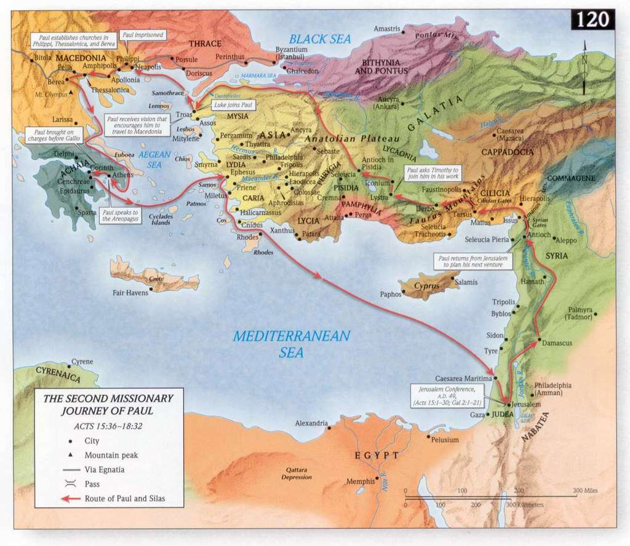

So called because of their founder, Epicurus.
Church tradition teaches that this couple became very instrumental in the growth of the church at Athens.
Many scholars believe that 1 Corinthians and 2 Corinthians are actually the first and third letter Paul wrote to the church.
Somehow they found out in Athens that Paul had traveled to Corinth. Once in Corinth, it wasn’t hard to find Paul: they just showed up at the synagogue on the Sabbath!
History teaches us that Crispus soon lost his position because of his conversion and the Jewish leaders became so infuriated with Paul that they began to try to kill him.
See 1 Thessalonians 3:2, 6.
For the Mosaic teaching on the Nazarite vow, see Numbers 6:1-21.
See Jeremiah 35:1-19.
Endnotes ? Sometimes ministers have to work a secular job in order to provide an income so that they can remain in a certain city and minister. Even today, some ministers speak of having to “make tents” in reference to this. Just a couple of thoughts here about this: - Paul did not make tents for forever, but for a short time. When Timothy and Silas arrived, he went back to ministering full time. - Paul’s focus while he worked secular work was still on winning souls. He did not get so wrapped up in tent making and making money that he forget why God had sent him there. He used the work as an opportunity to win Aquila and Priscilla to God! - Paul obviously had a trade learned that he could fall back on during his ministry when the situation dictated it. Such planning is simply wisdom on the behalf of all ministers of the Gospel.
There is uncertainty in the verse whether or not it was Paul or Aquila who had the Nazarite vow, the verse simply says “he.” Many preachers have taught that it was Paul who had taken the Nazarite vow, but the Greek wording of the verse tends to indicate that it was Aquila who had shorn his head. For instance, notice that it is Aquila's name that is last mentioned immediately before Luke says "he had a vow." It is also very unlikely that Paul, who had just written the letter to the Galatians so adamantly rebuking returning to live under the Mosaic Law would submit himself to this law. A more likely scenario was that Aquila, who had been a devout Jew before meeting Paul, had taken the vow of the Nazarite before converting to Christianity and had reached the end of his allotted time.
This list does not include Jesus Christ because Jesus was not a Nazarite in the sense that He had taken this vow of Moses’ law. Jesus was called a Nazarite because His childhood years were spent in the town of Nazareth and the term “Nazarite” was also used to mean people from that city. Many people have confused the two meanings and taught that Jesus Christ was a Nazarite in the same sense of Samson and John the Baptist. This is why many painters and artists regularly portray Jesus as having long hair, because they confuse the two meanings of Nazarite. Jesus was not under the Nazarite vow and therefore had short hair because for a man to not be under the vow and grow their hair long was against the Word of God and nature itself (see 1 Corinthians 11:14). The reason that the Nazarite vow called for a man to grow his hair long during the time of his vow was because it made him stand out among the normally short-haired men of Israel. As an obedient Jewish man who was not under the Mosaic Nazarite vow, Jesus would have had His hair cut short. All Christians in a spiritual sense become partakers of the Nazarite vow when we are baptized in Jesus' name and receive his precious Holy Spirit. We are separated unto God and a unique people (see I Peter 2:9 and Titus 2:14). When we willingly separate ourselves for our lifetime from the sinful habits and ways of the world, God responds by giving us Spiritual gifts, a great anointing, and Apostolic power!

